Property Management And Applications

# Introduction

### Overview

Property management is the daily oversight of residential, commercial, or industrial  real estate by a third-party contractor. Generally, [property managers](https://www.investopedia.com/terms/p/property-manager.asp) take responsibility for day-to-day repairs and ongoing maintenance, security, and upkeep of properties. They usually work for the owners of investment properties such as apartment and condominium complexes, private home communities, shopping centers, and industrial parks.

RESIDENTIAL PROPERTY MANAGEMENT : COMERCIAL PROPERTY MANAGEMENT : INDUSTRIAL PROPERTY MANAGEMENT :

# 1.2 Purpose

Property managers assist owners in creating budgets, advertise rental properties , qualify tenants and collect rent . They also company with the local landlord and real estate board laws and maintain the property .The property management indicates the need for real estate and physical property to be cared and monitored with accountability for and attention to its useful life and conditions . Property management involves the process, system and workforce required to manage the life cycle .Property management wants finding properties and physical properties to buy, rent , loan , and preparing and signing agreements and collecting rent and fees . They needs budgets, advertise rental properties. The hopes for the property management increase website traffic by 10 present in the next two months. We manage the best of the best property. We provide rental collection, property maintenance and financial in best ways

# 2 . Problem Definition & Design Thinking

## 2.1 Empathy Map

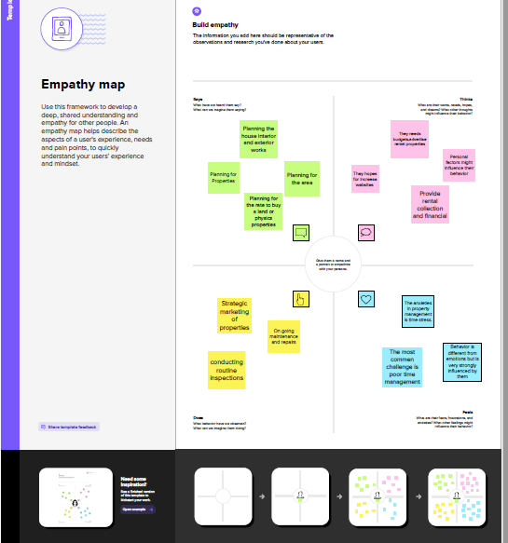

# 2.2 Ideation & Brain storming Map

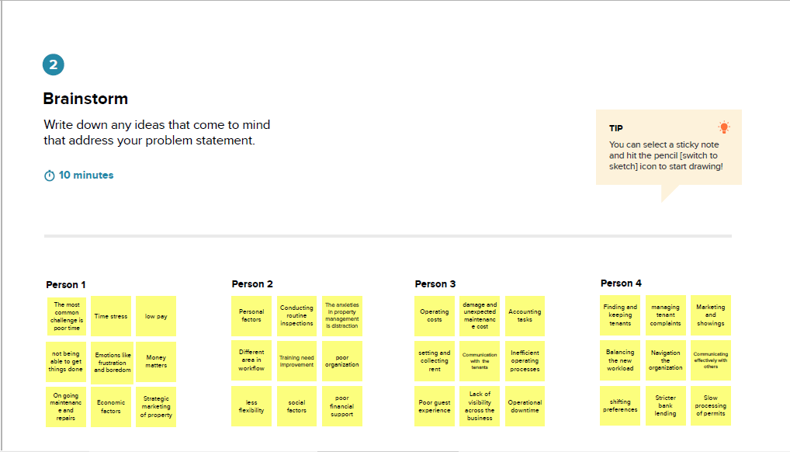

# Result

## 3.1 Data Model

To Navigate the setup page :

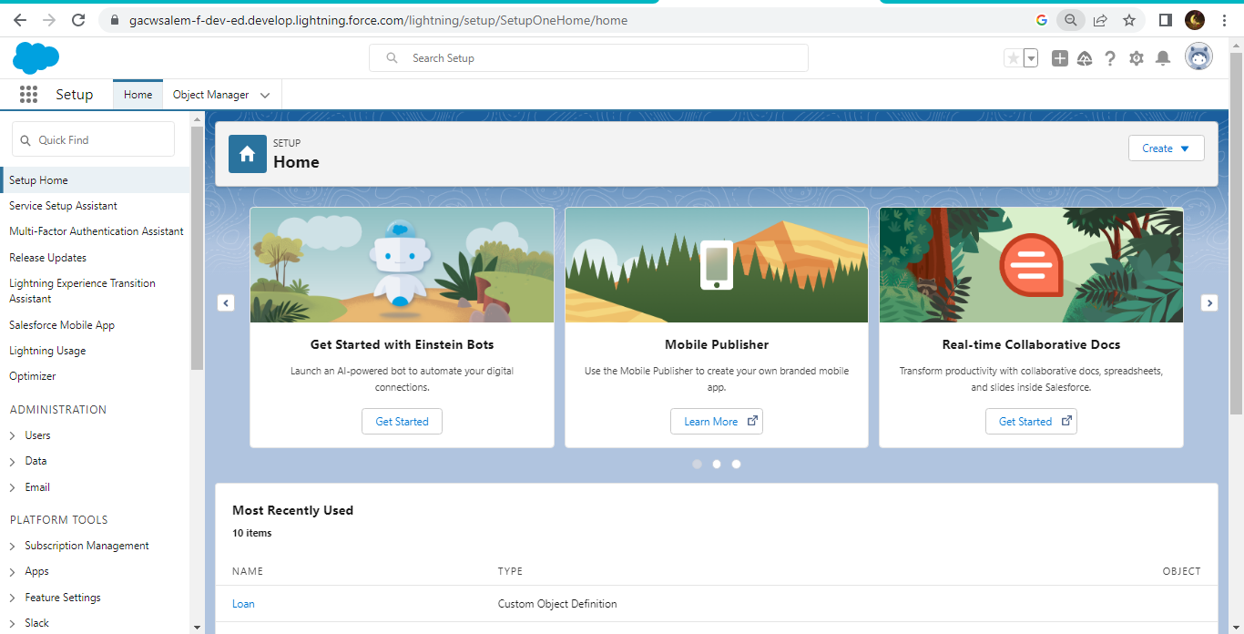

To Create an object

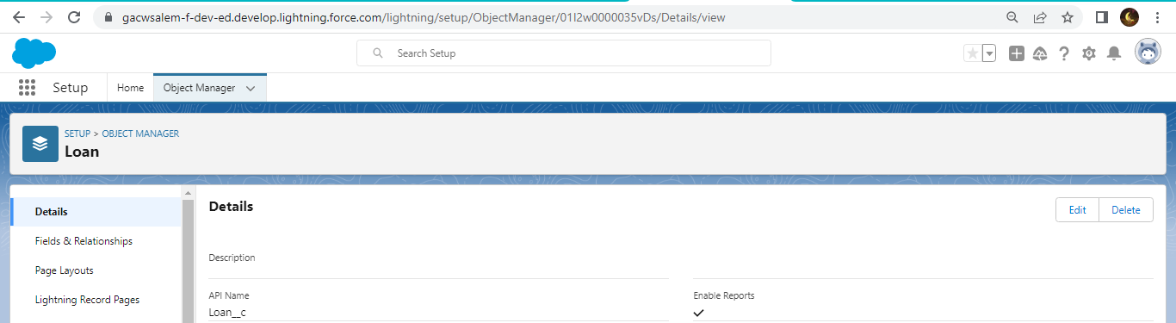

On custom object defining page

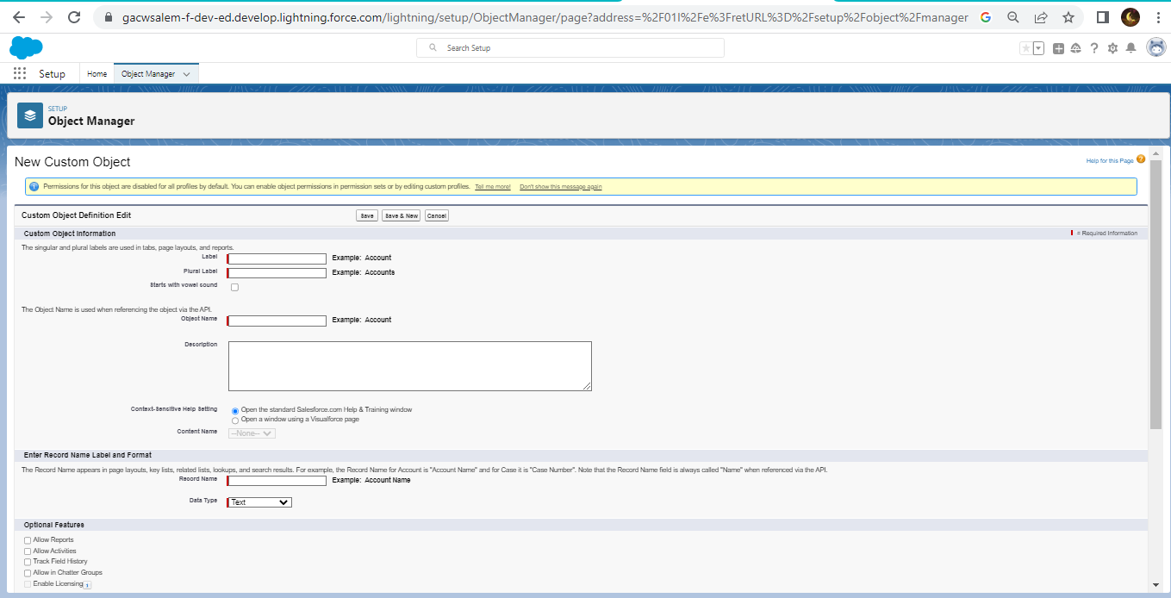

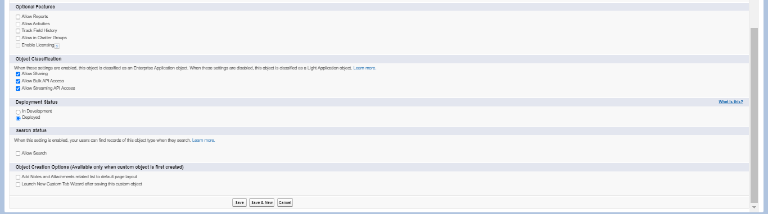

Create object buy

1. To create an object
2. From the setup page then click on object manager then click on create then click on custom object.
3. Enter the label name then buy
4. Plural label name then buyers
5. Click on allow reports
6. Allow search then save

Create object rent

1. To create an object
2. From the setup page then click on object manager then click on create then click on custom object
3. Enter the label
4. Plural label name then rents
5. Click on allow reports ,
6. Allow search then save

Create object loan

1. To create an object
2. From the setup page then click on object manager then click on custom object
3. Enter the label name then laon
4. Plural label name then loans
5. Click on allow reports
6. Allow search then save

Create the lighting tab :

To create a tab : ( Lead)

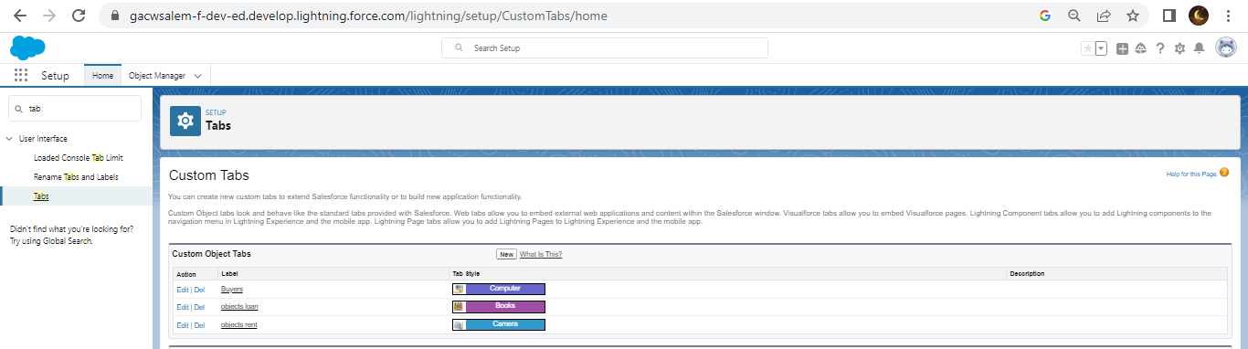

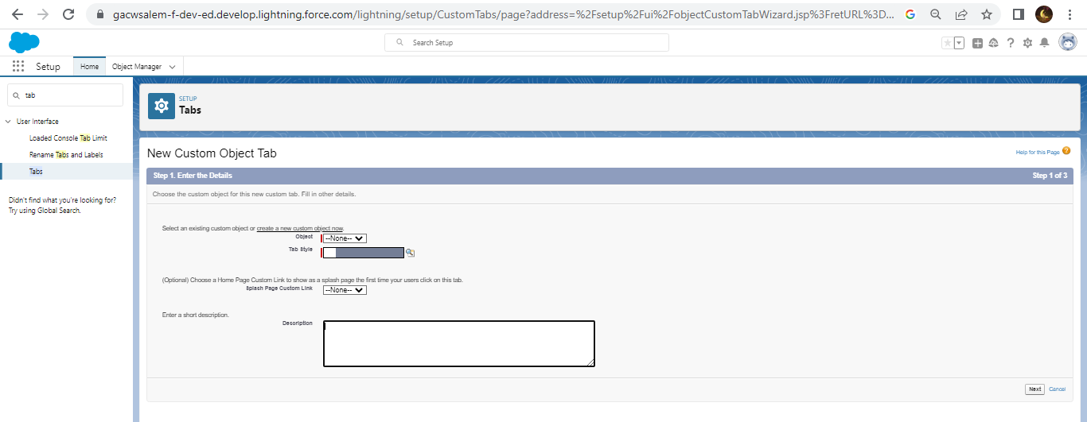

TO create a tab : ( Buy)





To create a tab: (Rent)





To create tab : ( Loan)





# Milestone 4: The Lighting app

To create the Lighting tab

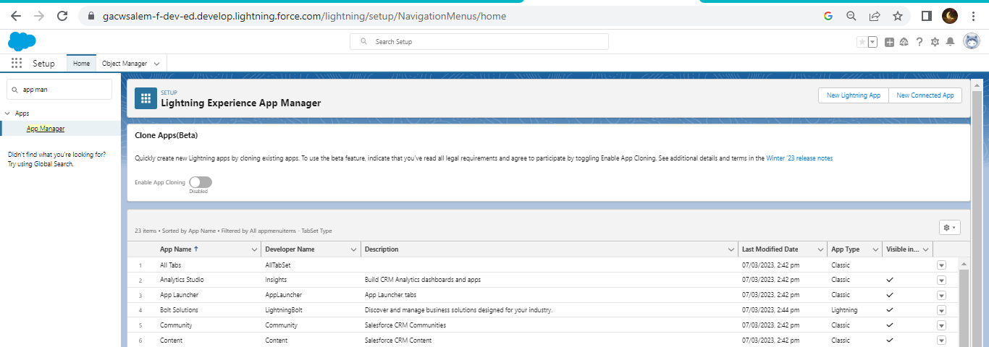

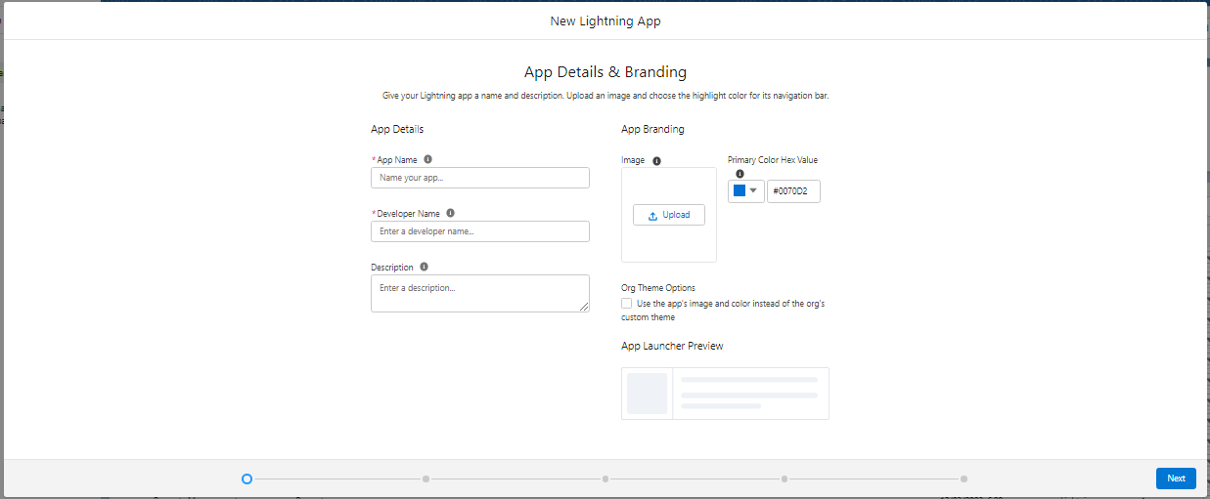

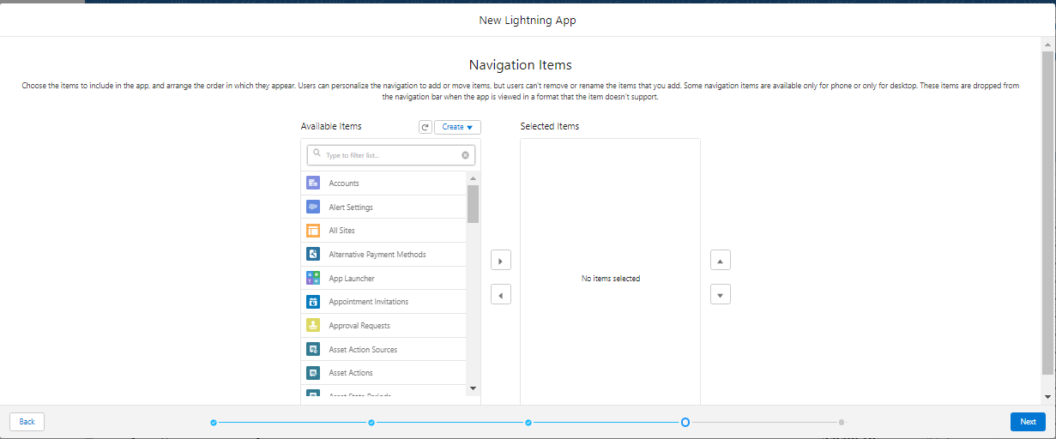

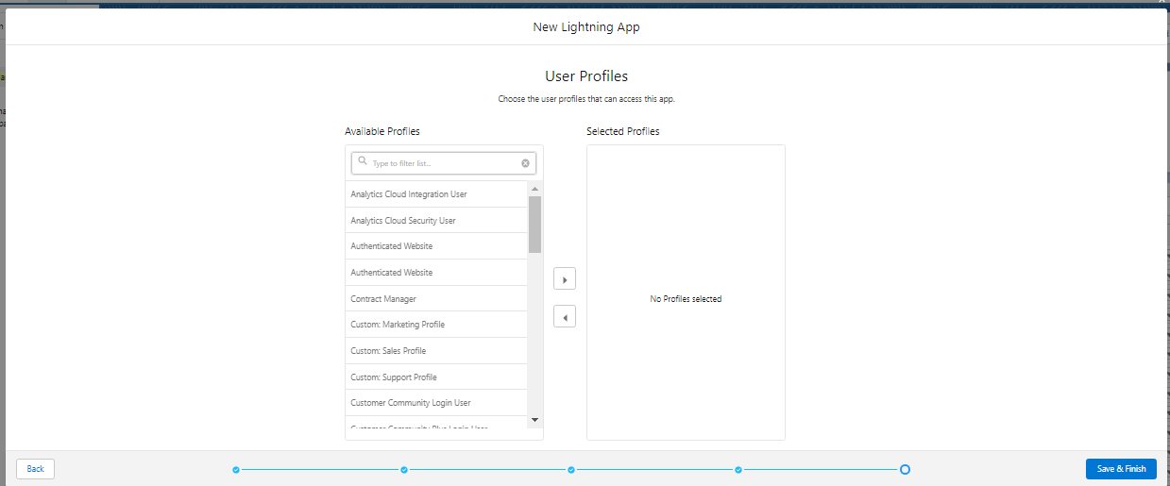

# Milestone 5

Activity 1

Create the Lead field

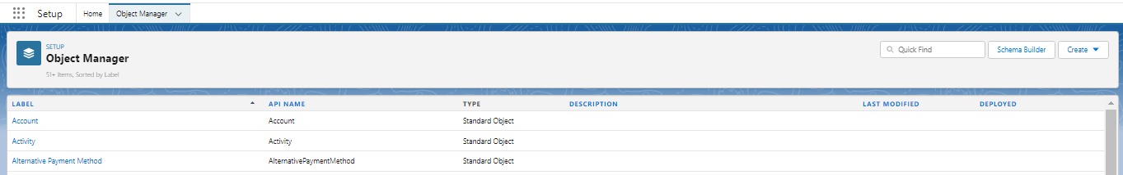

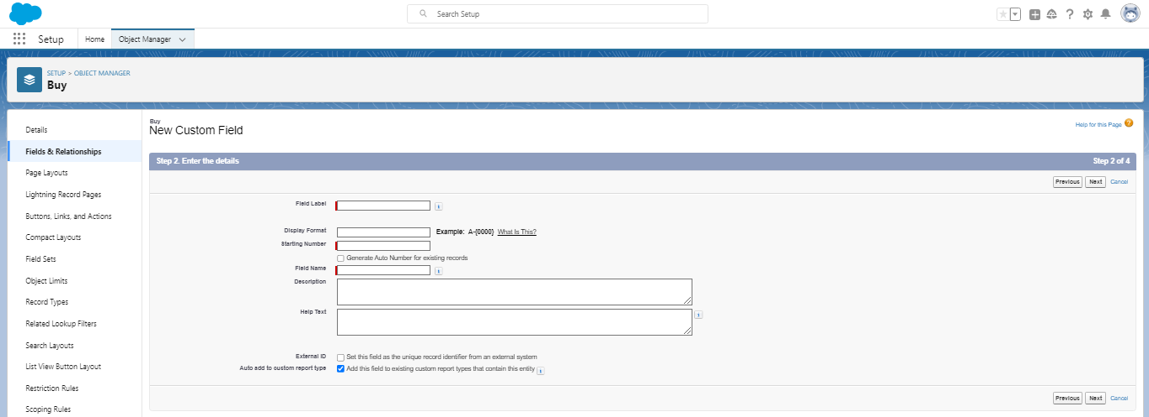

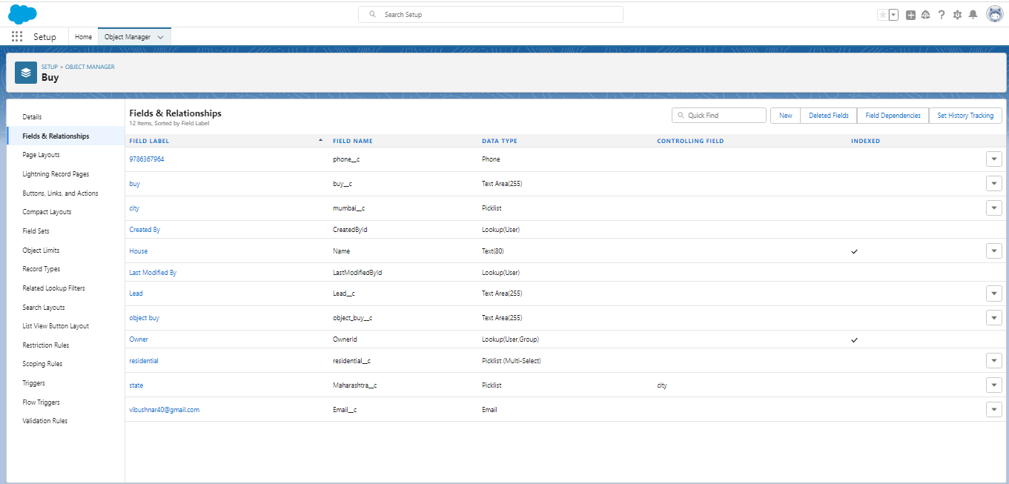



# Activity 2:

For object buy

1. Create field for buy
2. Create property type : (pick list) (residential, commercial, industrial)
3. Discount : percentage as the field data type
4. State : create the pick list field ( Maharashtra, Gujarath, Rajashthan) (field dependency)
5. City : take any city for field dependency
6. Annual amount to be paid

# Activity 3:

Create field for rent

1. Rent: auto number while creating the object R-{0000}

2. Rental city: select the text as the field data number (any city)

3. BHK type : pick list (1BHK,2BHK,3BHK)

# Activity 4

Create field for loan

1. Loan ID :auto generated field take it as auto number LN-{0000}

2. Interest rate (select field data type as currency)

3. Term (select the field data type as number)

4. Annual loan Field create the number as the field data type

5. Total loan installment Field create the number as the field data type

6. Loan repayment ( Field create the number as the field data type)

7. Loan amount ( select the field data type as formula)

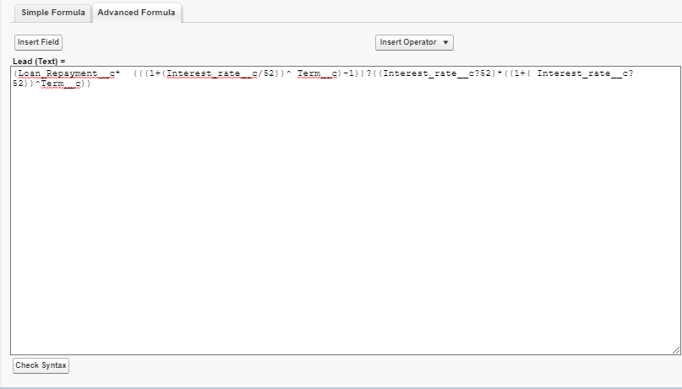

# Milestone 6 : Profile

Activity 1 :

To create a new profile :

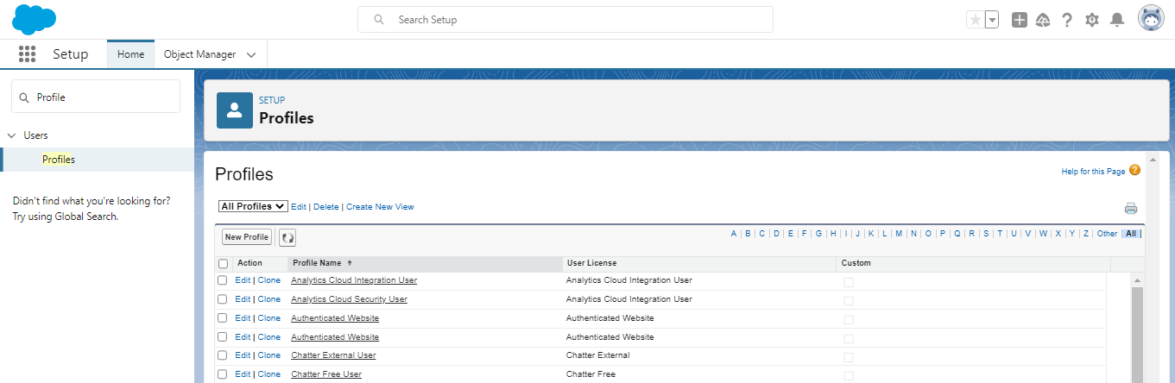

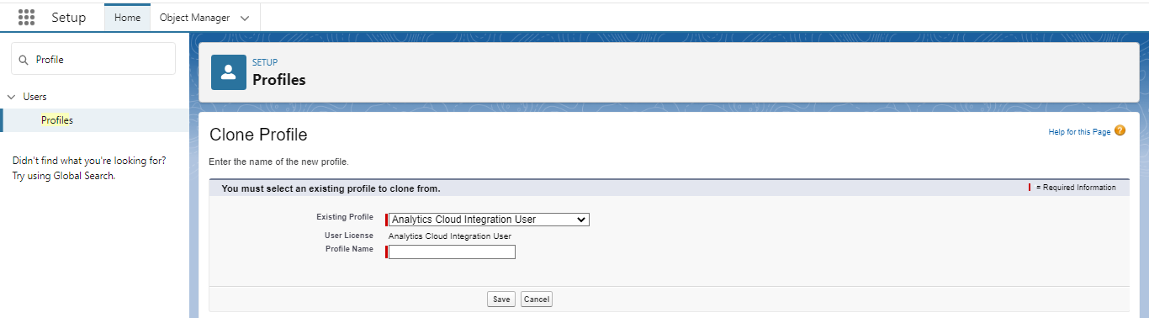

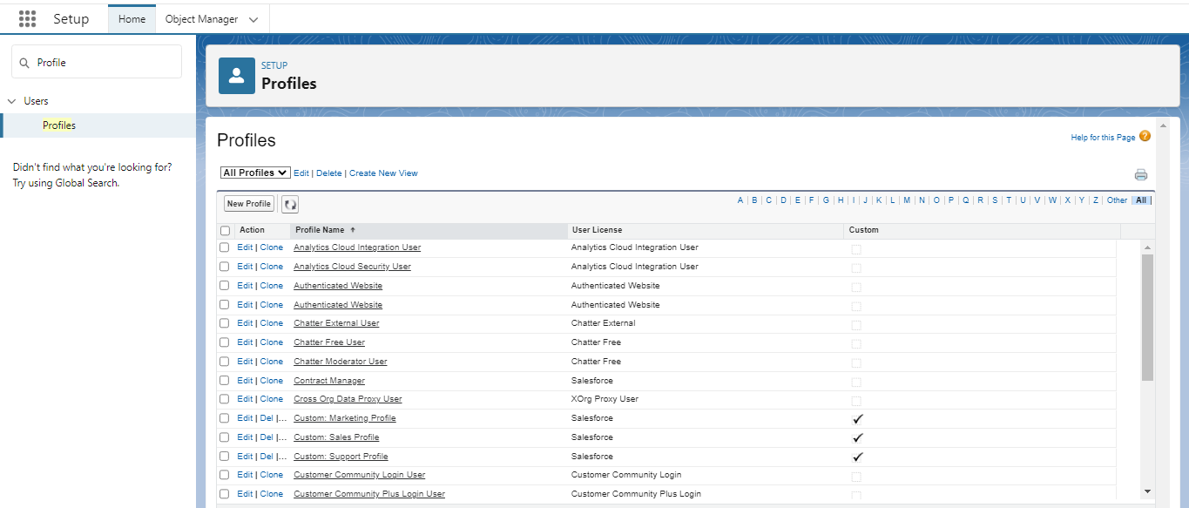

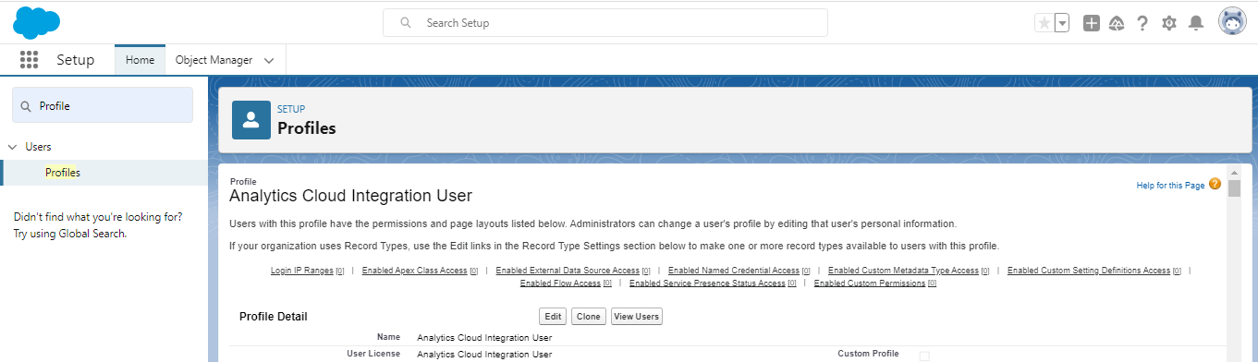

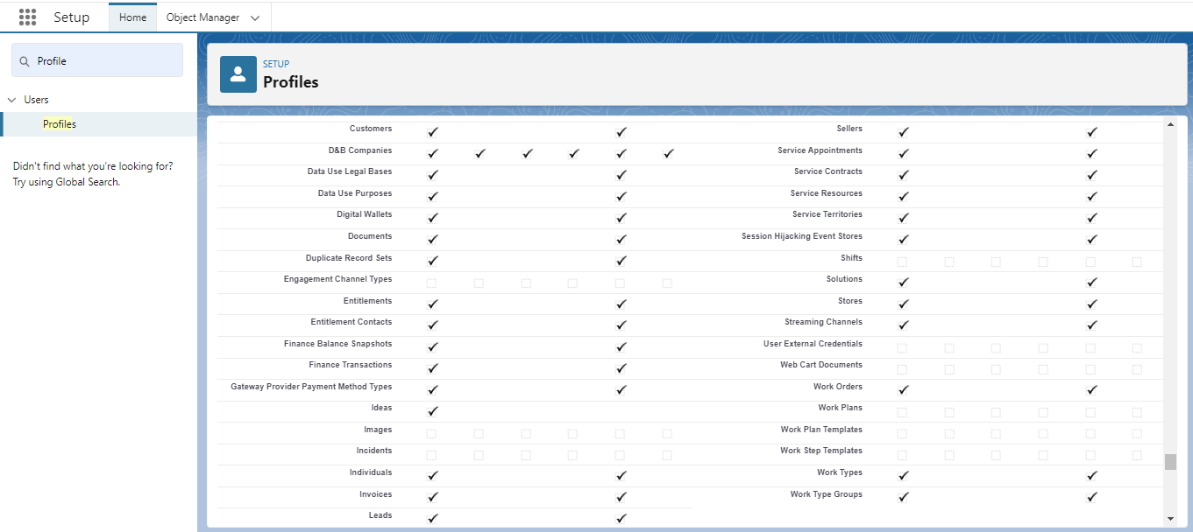

# Milestone 7 – New user

Create Users

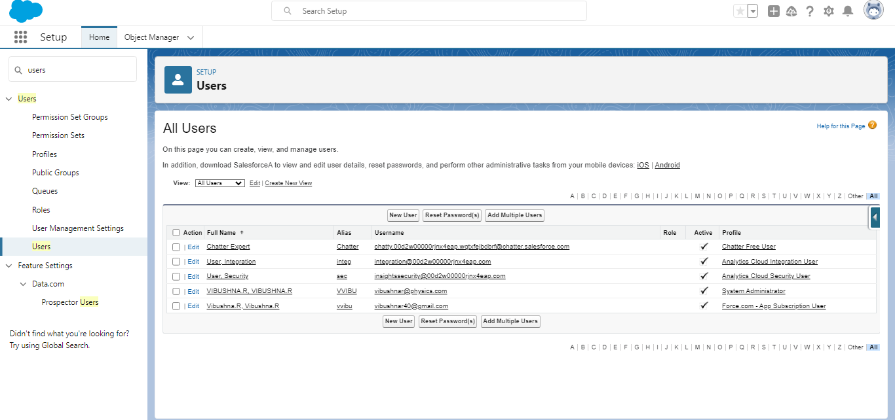

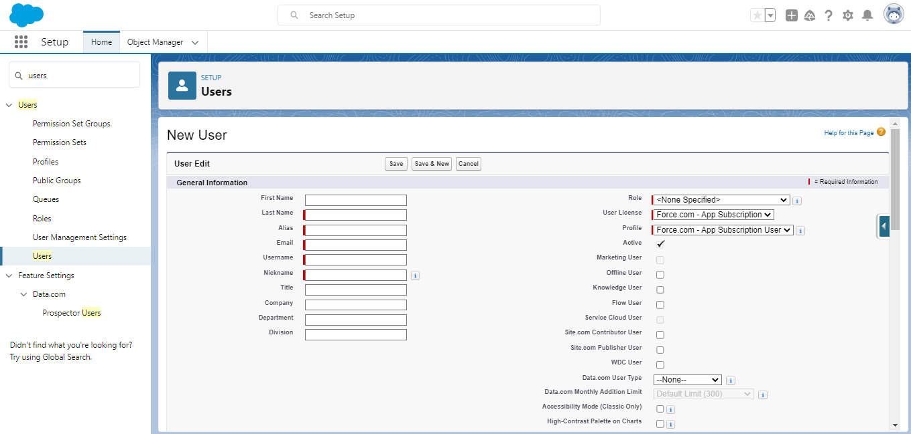

# Milestone 8 – Permission set

Creating the permission set

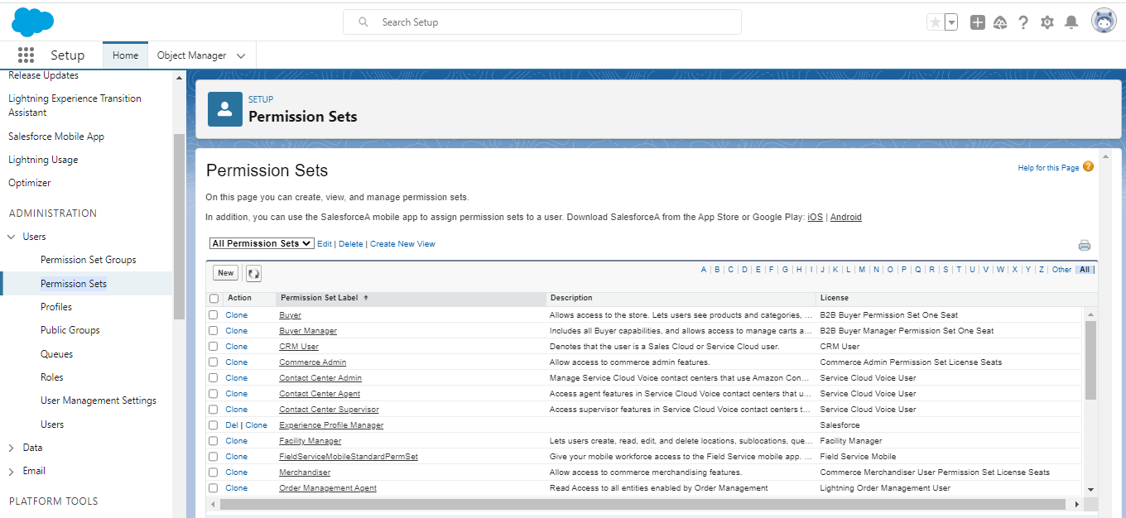

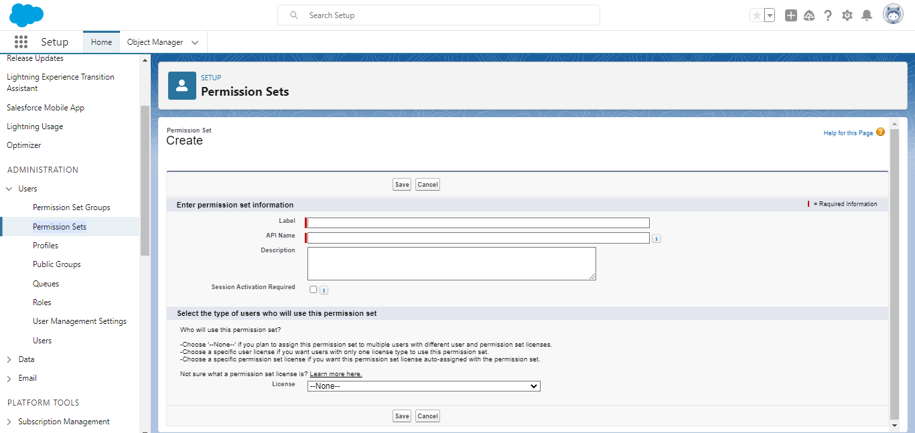

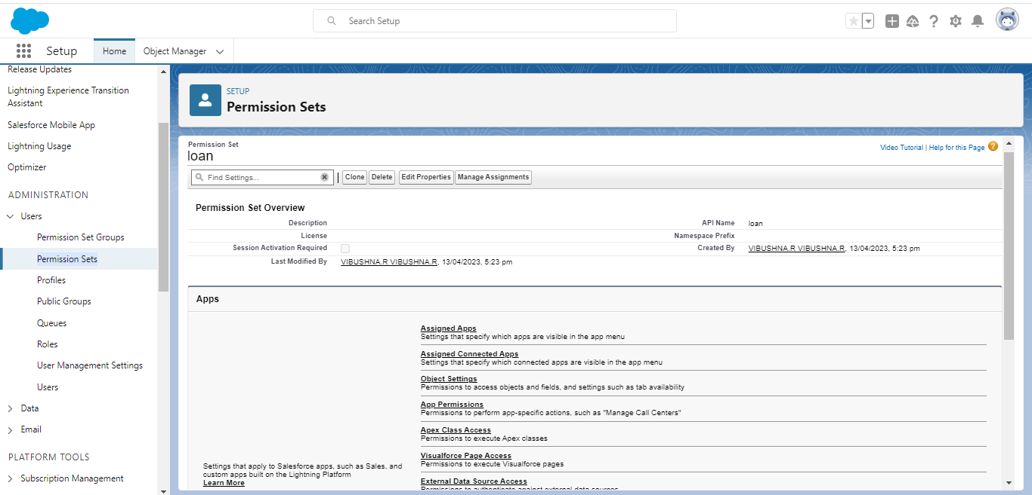

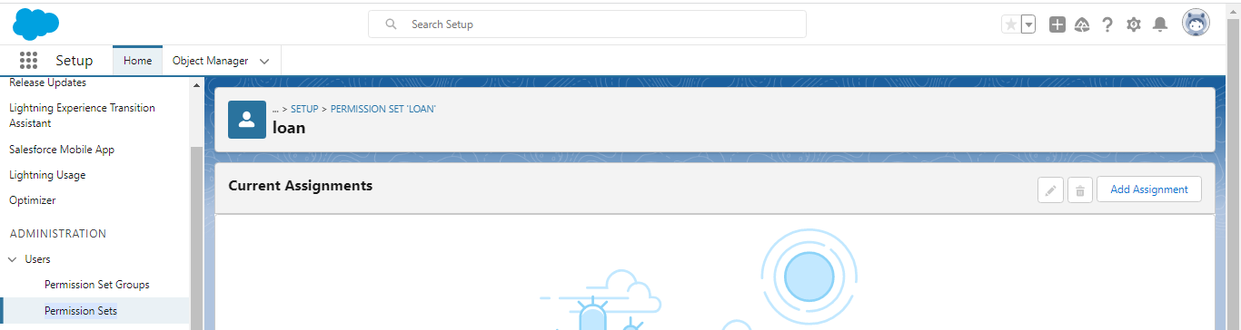

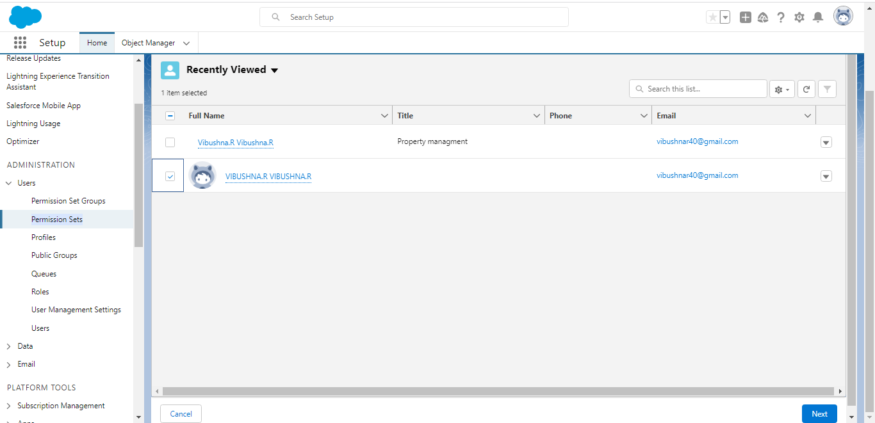

# Milestone 9- setup for OWD

Activity 1

Create OWD setting :

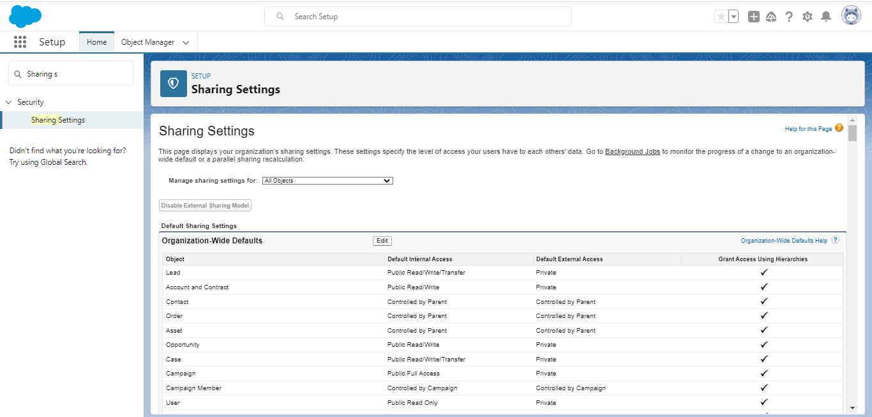

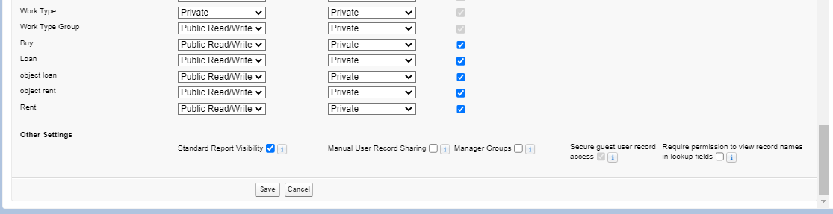

# Milestone -10 Report

Activity 1

Create report

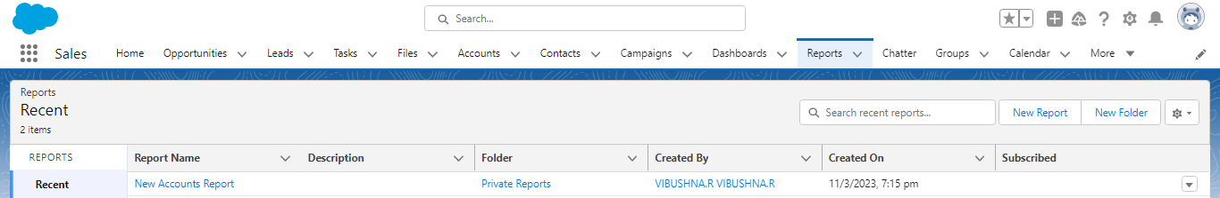

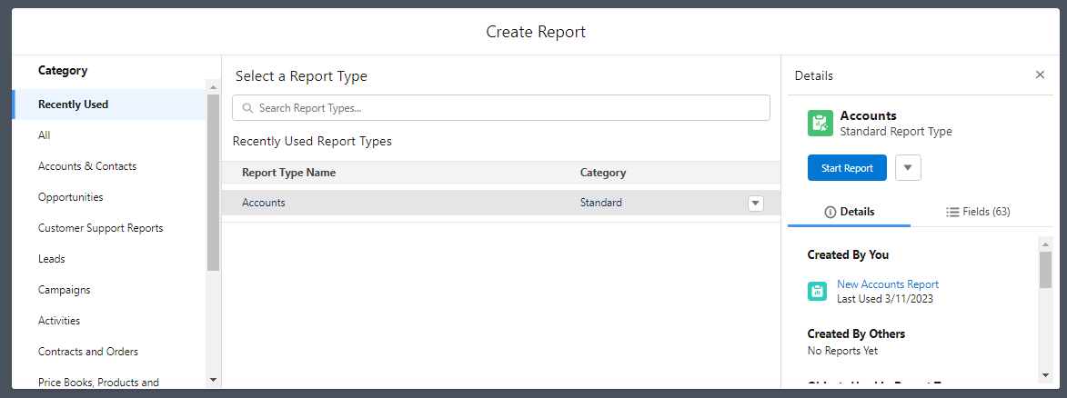

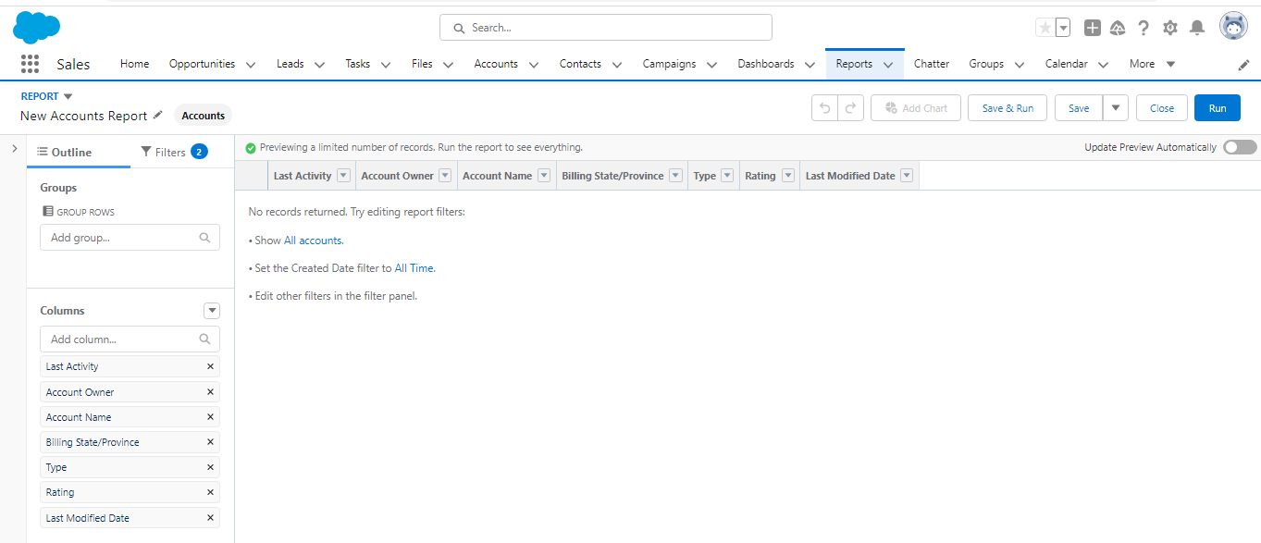

# Milestone -11 Dashboard

Activity 1

Create dashboards

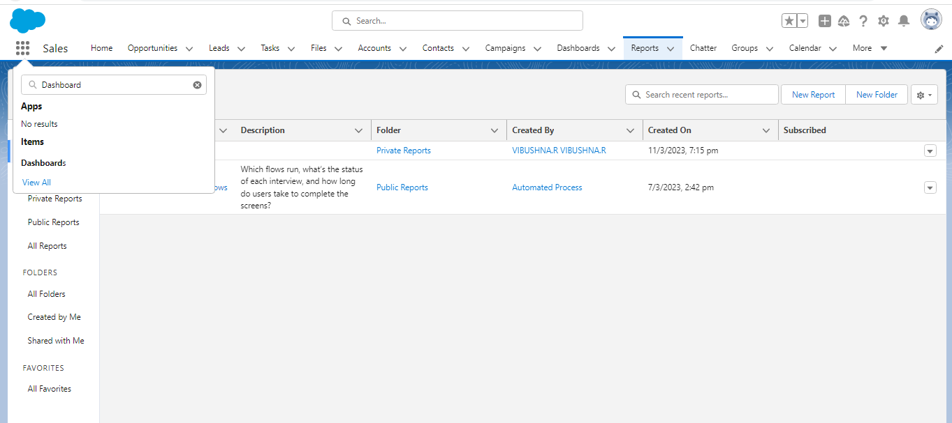

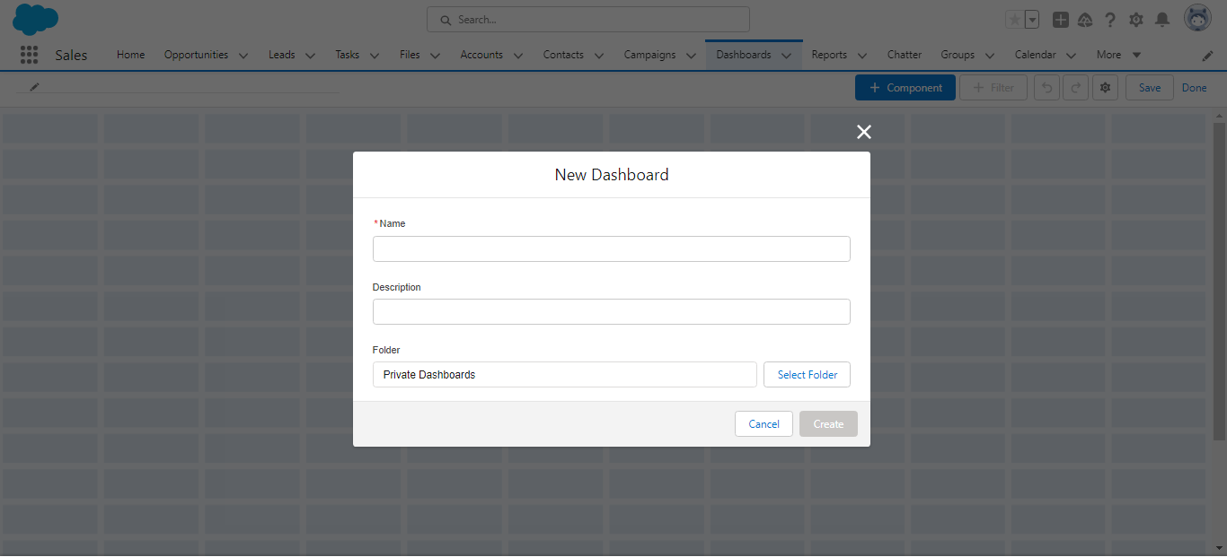

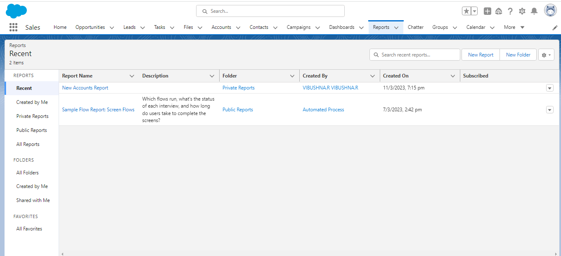

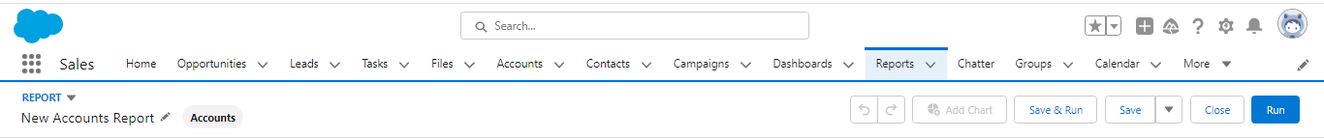

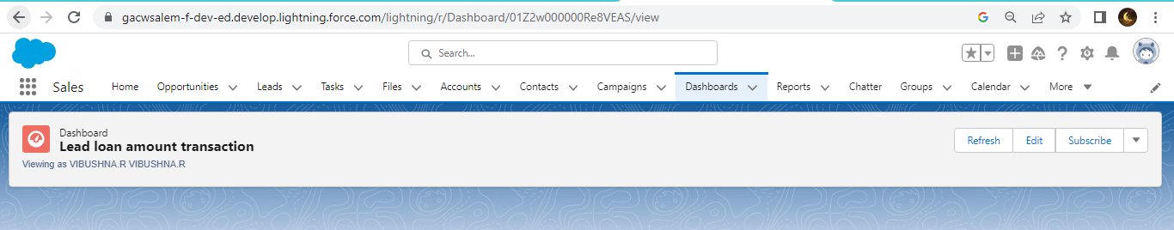

# Trailhead profile public URL

Team Lead – https://trailblazer.me/id/rvibushna

Team member 1 –https://trailblazer.me/id/tthenmozhis

Team member 2 –https://trailblazer.me/id/tkumar2003

Team member 3 –https://trailblazer.me/id/vvinothi1

# Advantages & Disadvantages

## Advantages :

**1. High-quality tenants**

Tenant screening can be a complex process, and if you don’t have sufficient experience in the real estate industry, you might end up choosing a bad tenant. The main problem with bad tenants is that it can be quite difficult to make them leave your property. Good property management companies have a reliable and verified screening process that helps them select tenants who will:

* Rent long-term
* Pay rent on time
* Minimise the wear and tear of the property
* Cause fewer problems

A property management company that has been in the business for a long time, has seen thousands of tenant applications. This will help them dig into facts about the potential tenants quicker and identify red flags. If you allow a management company to handle the tenant screening, you are also avoiding rental scams that are directed at property owners.

## 2. ****Less legal problems****

Experienced landlords are aware of the fact that a single bad tenant can cause a great deal of financial and legal headaches. A high-quality property management company is armed with a lot of knowledge and they can protect you from potential lawsuits and vulnerabilities. Each Australian state will have their own laws that can affect a landlord. Additionally, you also have the federal law that will cover the following aspects:

* Screening tenants
* Property conditions and safety
* Tenant evictions
* Unit inspections
* Signing and terminating leases
* Collecting and handling rent and security deposits

**3. Shorter periods of vacancy**



A professional property manager will help you handle the following tasks that prevent your properties from staying vacant for too long:

* **Prepare the properties for rent** - A property management company will know exactly what cosmetic improvements must be done to the units in order to maximise your revenue.
* **Determine the optimal rent rate** - Setting the rent too high and it might take too long to find tenants, too low and you might be losing money every month. It is crucial to determine the right price and doing it requires knowledge of the local real estate market, data on similar units, and access to professional rental rate tools.

### 4. ****Long-term tenants****

If tenants don’t rent your units for long periods of time, you will have to deal with a series of issues like lost rent, having to clean the property, change the locks, repaint walls, replace carpets, make small repairs, go through the tenant screening process and marketing campaigns again. These things take time and can be quite expensive, but can be avoided by keeping your tenants happy.

[A good property manager](https://www.bricksandagent.com/com/bricksandagent/www/blog/property-managers-checklist.html) will have a tenant retention policy that is time-tested. These programs are essential and require a systematic and consistent approach, which is where a high-quality property management company will shine. A happy tenant is more likely to rent long-term than one who is not happy with the property or with the landlord.

### 5. ****More efficient rent collection****

Handling the collection of rent and late fees is an extremely important aspect of property management. To ensure consistent and reliable cash flow, rent must be collected on time every month, and it’s important that tenants understand that.

By hiring a professional property manager, the landlord puts a buffer between themselves and tenants, allowing them to be the bad cop who has to listen to tenants’ excuses, collect rent, and handle evictions if necessary.

Being too permissive, tenants may, walk over you. It should be made clear how important each clause in the lease is and if breach it there can be consequences.

The eviction process is another important aspect that a property manager will handle. There are strict laws that regulate this process and doing it the wrong way can be a big mistake. A skilled professional knows the law and aims at making the best out of bad situations. Not having to handle a potential eviction yourself is a very compelling reason to hire a specialist.

### 6. ****Lower repair and maintenance costs****



Tenants are always happy if you offer them good maintenance, not to mention that by doing that you also preserve the value of your assets. By hiring a property manager you gain access to professional maintenance and a network of  [licensed, insured, and bonded contractors](https://www.bricksandagent.com/blog/hiring-licensed-tradies). These contractors are trustworthy and have been vetted for quality work and good pricing. This can save you a lot of money compared to hiring someone from the yellow pages.

Additionally, a property management company will also be able to get discounts on account of their great volume of managed properties.

# Disadvantages

While a property management system may ultimately help your business run more smoothly, it’s important to consider the disadvantages to determine if it’s right for your property before investing.

### You’ll be dependent on one vendor

Property management systems allow you to connect every aspect of your business through one application. However, this may make it more difficult to use other third-party products that may be more useful to your business, such as payroll or accounting programs.

While some property management systems may allow integration with third-party products, the implementation is not always smooth and may cause both products to have operational issues. You may need to purchase additional products later if you want to add services that your software vendor doesn’t offer, such as self-check-in kiosks, email marketing databases or guest communication platforms. If you choose different vendors for these products, you’ll be back to managing several different systems instead of one property management solution.

### Cost can be prohibitive in the beginning

If you’re a small, family-owned business in a non-tourist destination, it can be difficult to come up with the cash for an all-in-one property management system right away. Over time, these solutions pay for themselves in saved time and increased bookings, but you’ll want to make sure you choose the right product for your type of business.

Because the software is often proprietary and may not accept or play well with other tech products, you may be forced to abandon your property management system if it doesn’t work for you, or spend more money to find a more appropriate solution.

### All-in-one is not always best.

For larger hotels, relying on property management software that claims to do everything can be a hassle and may actually require you to purchase other products or services. Software products usually perform one to three core functions very well. For instance, your chosen property management system may do a very good job of collecting and organizing bookings, assigning staff and keeping an up-to-date, rotating log of maintenance requests.

However, the same system may not have an optimal accounting program, or may not have a marketing function at all. If these functions are essential to your business – and they often are for very large or very busy properties – you’ll need to either purchase additional software or hire additional staff to ensure these functions are working properly.

# Applications

The most common challenge faced by property managers is poor time management . the frustration include internal element such as debt , areas where your workflow or training need improvement and other pain in your day to day operations . the anxieties in property management is time stress , distractions, low pay , not being able to get things done. The above problems sloved to consentrate time and peaceful mind.

# Conclusion

In conclusion, Property Management System (PMS) software is very crucial for all the Hotels. Especially Opera PMS constitutes the most appropriate PMS software for Hilton Athens. It is user friendly, connects with Central Reservation System (CRS), Point of Sale (POS) etc. and provides all the tools the hotel needs in order to operate effectively. Property management requires people from all different backgrounds to work as a high performing team. As the owner of the firm and senior leader, I must be committed to diversity by removing my bias about young women and men. Now that I am aware and acknowledge my bias, I can develop a strategic plan that aligns with the firm’s goals. Social media can encourage prejudice therefore it should not be the primary source of identifying candidates. Hiring human resources professional to screen resumes and participate in interview selections will also help mitigate bias in the firm. To create a competitive firm with growth and diversity , leader acknowledge their bias presiption and find ways to eliminate them.

# Future scope

### Industry segmentation and property management (PM) specialization

In the near future of property management, both segmentation and specialization will play a significant role.  
  
As for industry segmentation, 2020 has shown that those who offer a property in a particular segment have more secure positions in the market than those dealing with everything from low-rent apartments to luxury mansions.  
  
While segmentation helps managers set themselves apart from the competition, specialization brands them as reliable rental professionals. With property management activities starting to involve more technologies, skills, and regulations to be aware of, it becomes evident that prospective renters will look for certified professionals in the market in the first place.

### Emerging property management startups

In 2020, COVID-19 served as a catalyst for many companies to upgrade their tech stacks and order [software development for startups](https://fayrix.com/services/startups). As remote communications became a priority worldwide, rental agents started to look for ways to maximize the effectiveness of online interactions with their prospective clients. Automated messaging tools and video calls all work together towards a single goal.  
  
This doesn't only apply to property managers and potential clients or tenants. Property management software allows managers to schedule laundry services, assign cleaning and disinfecting procedures, and much more.  
  
Intelligent buildings, in turn, are no longer perceived as something fancy. Keyless entry systems and online card payments take in-person meetings out of the equation, while the ability to regulate heat, temperature, and moisture in the house is becoming a part of good hygiene habits.